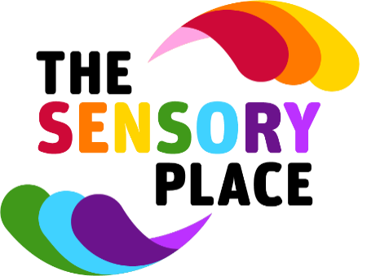

Membership Form 2022
Please complete this membership form for any child you would like to receive packs, attend events and activities. This can include siblings or close family members. Please return your completed form to Thesensoryplace19@outlook.com with the relevant payment. It is £5 for six months or £10 for twelve months per child. Payment can be made either by Paypal to thesensoryplace19@outlook.com or to account number 44943046 and sort code 09-01-29.
Name
Address

Postcode
Phone Number
Email
Membership required (Please tick) | Six months ☐ Twelve months ☐
Member 1 (Name/Age)
Disability

Member 2 (Name/Age)
Disability

Member 3 (Name/Age)
Disability

Member 4 (Name/Age)
Disability

Member 5 (Name/Age)
Disability

Are there any allergies we should know about?

Do you give photo consent? *Please note photos may be shared with funders, on posters, social media pages etc – photo consent can be withdrawn at any time.
Is there anything else you would like us to know?

The Sensory Place take your privacy seriously and will only use your personal data for our internal membership records. We will not share your details with any other organisation. Please tick to consent to us securely using and storing your information in line with our Data Protection and Privacy Notice. ☐

The Sensory Place offer a safe, supportive, non-judgemental environment.

- All children must be accompanied by a responsible adult, over the age of 18, who must remain with their child at the activity at all times.
- Staff/volunteers may support activities to help maximise your child’s enjoyment, they are not however a replacement for parental supervision. The Sensory Place does not accept responsibility for the supervision of children unless the activity specifically states that it is a supervised session.
- Please respect all users of The Sensory Place and be tolerant of all individual needs and behaviours.
- Parents/carers should note that whilst every consideration has been given for the safety of children using the facilities, The Sensory Place cannot be held responsible for accidents which occur as a result of your child playing on or using any equipment.
- Please respect all equipment and the environment you are in, ensuring areas are left tidy when leaving them.
- Please report accidents, incidents or breakages to us as soon as possible.
- Please be considerate of the privacy of if taking photographs at any activities or events, these should include only those you have permission for, i.e. your own family/friends, particularly when sharing on social media.
- Smoking, including e-cigarettes, drug or alcohol use is not permitted at any activity or event.
- Abusive language, violent behaviour, or wilful damage or theft will not be tolerated at any time.

Failure to adhere to these terms and conditions could result in you being asked to leave the activity or in extreme circumstances your membership being cancelled without refund.

I have read the terms and conditions below and agree to adhere to them. ☐

